Project Design Phase
Solution Architecture
Date | 4 September 2026
Team ID | Servicenow
Project Name | Automated Network Request Management in ServiceNow
Maximum Marks | 4 Marks

Solution Architecture:
Solution architecture is a complex process – with many sub-processes – that bridges the gap between business problems and technology solutions. Its goals are to:
- Find the best tech solution to solve existing business problems.
- Describe the structure, characteristics, behavior, and other aspects of the software to project stakeholders.
- Define features, development phases, and solution requirements.
- Provide specifications according to which the solution is defined, managed, and delivered.

Proposed Architecture — Automated Network Request Management in ServiceNow:
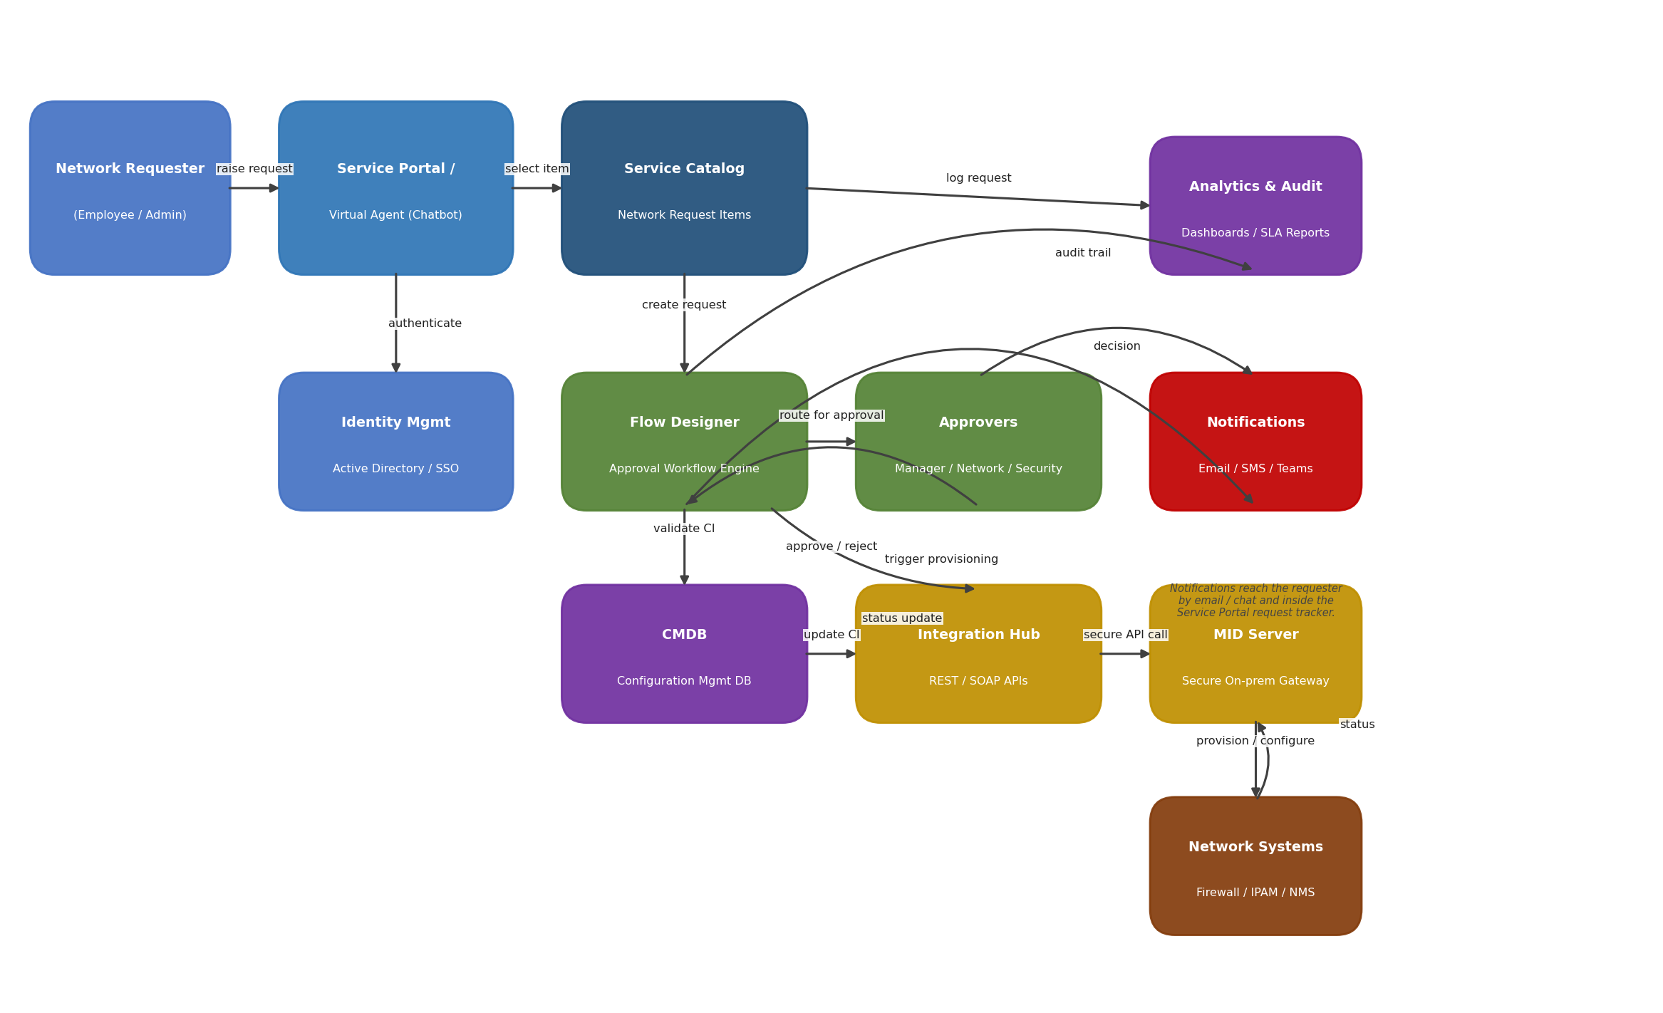
Figure 1: Solution Architecture and data flow of the Automated Network Request Management application on ServiceNow
Architecture Flow:
- The requester raises a network request through the Service Portal or a Virtual Agent chatbot and is authenticated via Active Directory / SSO.
- The request is created from a structured Service Catalog item and passed to the Flow Designer approval workflow engine.
- Flow Designer routes the request to the relevant approvers (Manager, Network Team, Security) based on request type and risk; the decision (approve/reject) is sent back to the workflow.
- On approval, Flow Designer validates the configuration item (CI) in the CMDB and triggers the Integration Hub to fulfil the request.
- The Integration Hub calls network systems (Firewall, IPAM, Network Management System) through a secure MID Server gateway to provision or configure the requested access.
- Network Systems return a status back through the MID Server, and the CMDB is updated with the new configuration state.
- The Notifications engine informs the requester of approval decisions and fulfilment status by email, chat/Teams, and inside the Service Portal request tracker.
- Every request, approval, and fulfilment action is logged for Analytics & Audit, powering SLA dashboards and compliance reporting.

